|  |  |  |  |  |  |
| --- | --- | --- | --- | --- | --- |
| Date | 29-Nov-22 | | | Tester Name | Mayuri Patel |
| Environment | Penfax - Test | | | Login used |  |
| Operating System | Windows | Version: | Update: | | |
| Software Used | Edge | Version: | Update: | | |
| Select Software | Version: | Update: | | |
| Release version | 22.4.1 | | | | |
| Title |  | | | | |
| Test Type | Regression | | | | |
| Test Scenario | Change a person's taxes the same day as a monthly payment | | | | |
|  |  | | | | |
| Expected Results |  | | | | |
| Pass/Fail | Pass | | | JIRA# | N/A |

Describe your steps with screenshots:

Find a VPB active member whose scheduled withdrawal is current

Open that member profile

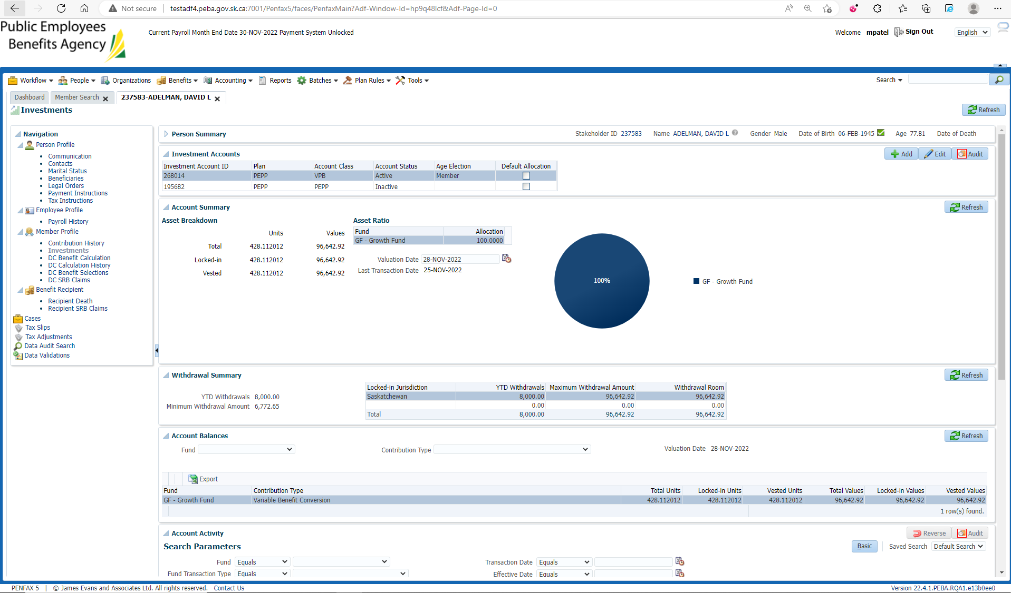

Current scheduled Withdrawal

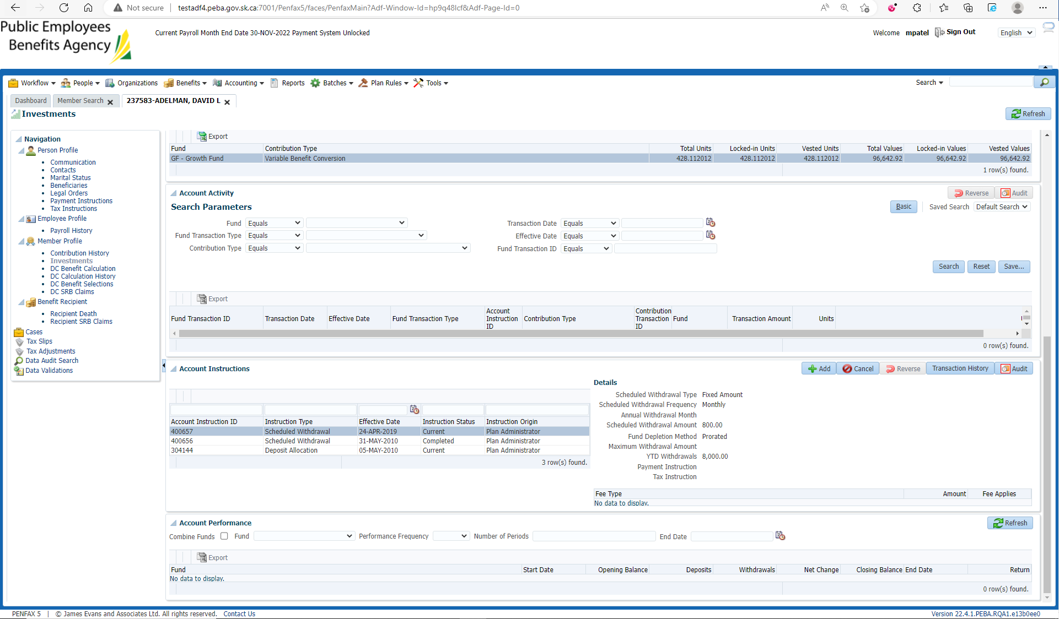

Benefit Recipient🡪 Income Benefit🡪 Tax Instruction

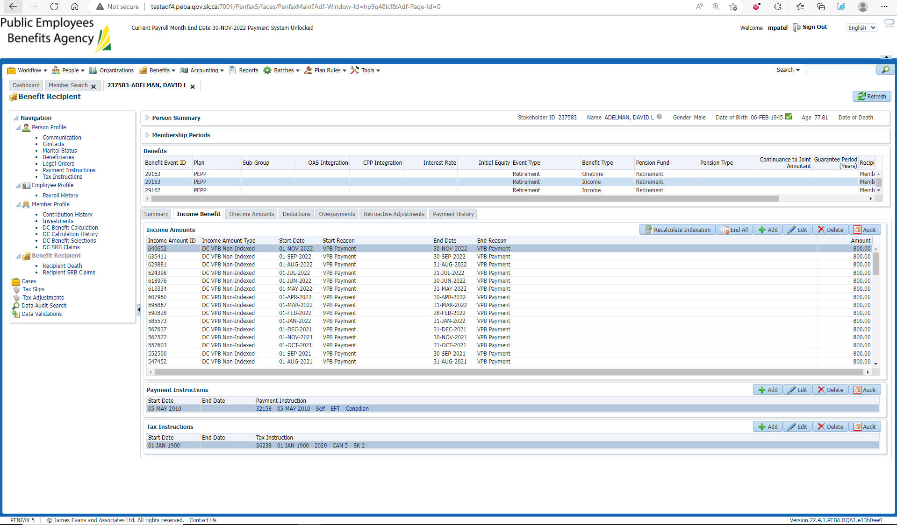

Add New tax Instruction and Save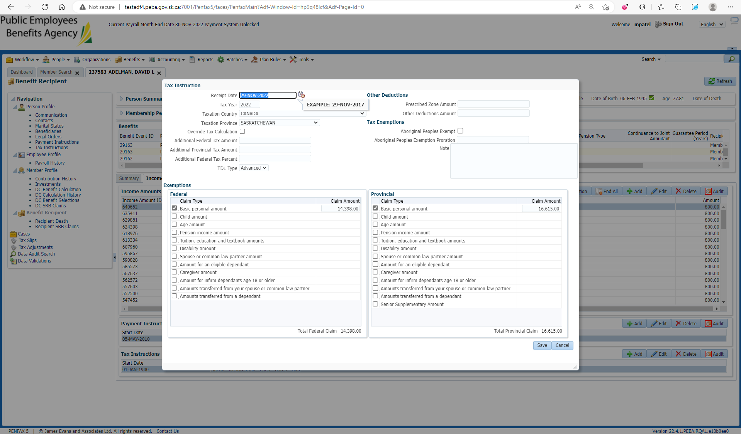

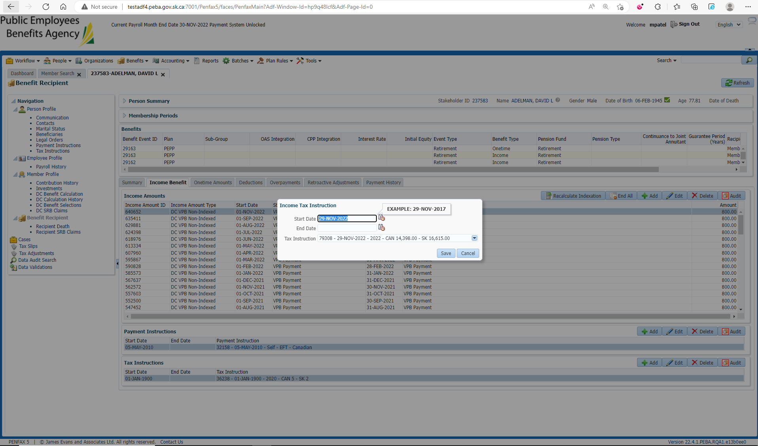

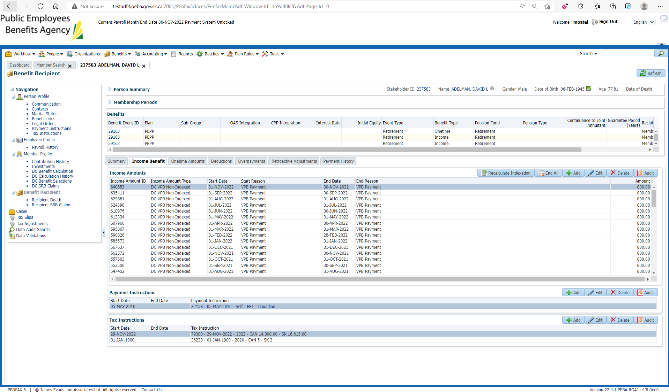

After Overnight PIT Batch

Open that member Profile again

Benefit Recipient🡪Income Benefit

Make sure schedule withdrawal is processed using newly added Tax Instruction

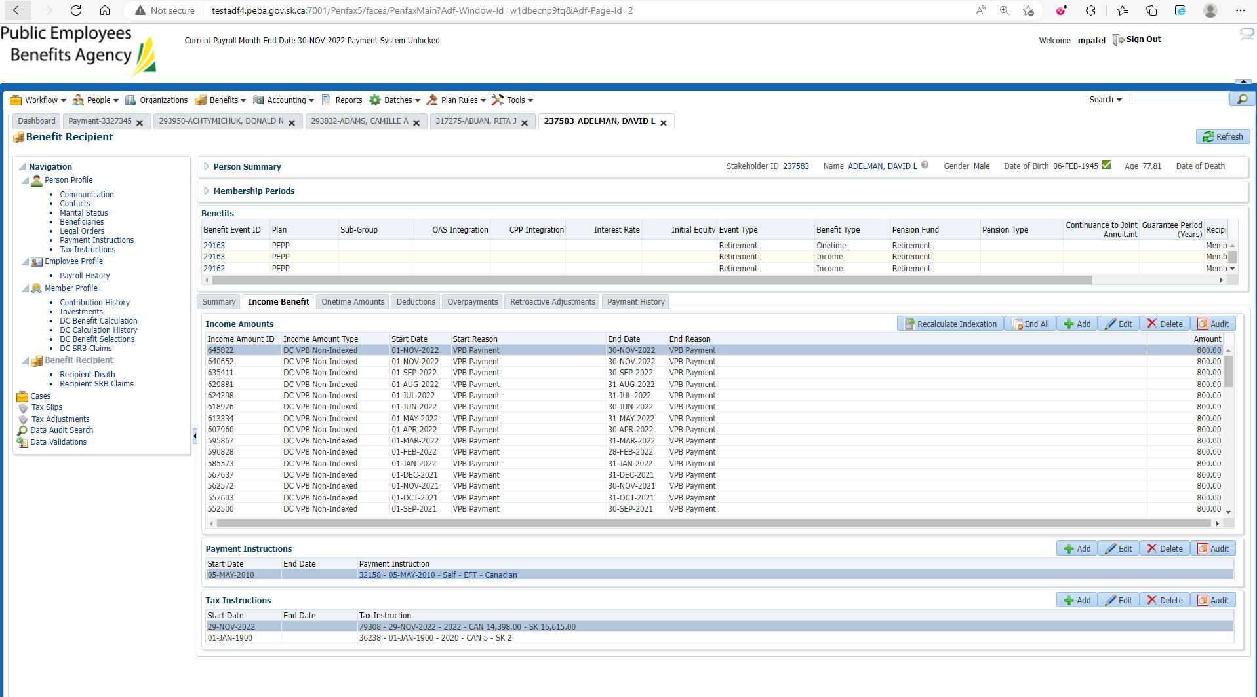

Make sure for the scheduled withdrawal, Under Investments🡪 Account Activity

